Quiz.

In the Hypothetical Machine the contents of memory was as shown. And PC contents is 300. Show the contents of memory and PC, AC, IR after Execute three instructions (three fetch cycle and there execute cycle)..

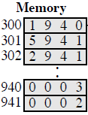

$. Answer question 1'
1.
-Fetch
AC: 0000 IR: 1940 PC: 300
940: 0003 941: 0002
-Execute
AC: 0003 IR: 1940 PC: 300
940: 0003 941: 0002
2'.
-Fetch
AC: 0003 IR: 5941 PC: 301
940: 0003 941: 0002
-Execute
AC: 0005 IR: 5941 PC: 301
940: 0003 941: 0002
3'.
-Fetch
AC: 0005 IR: 2941 PC: 302
940: 0003 941: 0002
-Execute
Ac: 0000 IR: 2941 PC: 302
940: 0003 941: 0005

Show the contents of PC , AC and IR and memory after the Execute of each instruction of the following program on the Hypothetical Machine:
300 LOAD 550
301 ADD 551
302 STORE 600

Where the contents of memory at 550 is 3 and at 551 is 4.

- $. Answer question 2'
- 1
-Fetch
AC: 0000 IR: 1550 PC: 300
550: 0003 551: 0004 600: 0000
-Execute
AC: 0003 IR: 1550 PC: 300
550: 0003 551: 0004 600: 0000
- 2
-Fetch
AC: 0003 IR: 5551 PC: 301
550: 0003 551: 0004 600: 0000
-Execute
AC: 0007 IR: 5551 PC: 301
550: 0003 551: 0004 600: 0000
- 3
-Fetch
AC: 0007 IR: 2600 PC: 302
550: 0003 551: 0004 600: 0000
-Execute
AC: 0000 IR: 2600 PC: 302
550: 0003 551: 0004 600: 0007

The following figure provide the main characteristics of Hypothetical Machine..
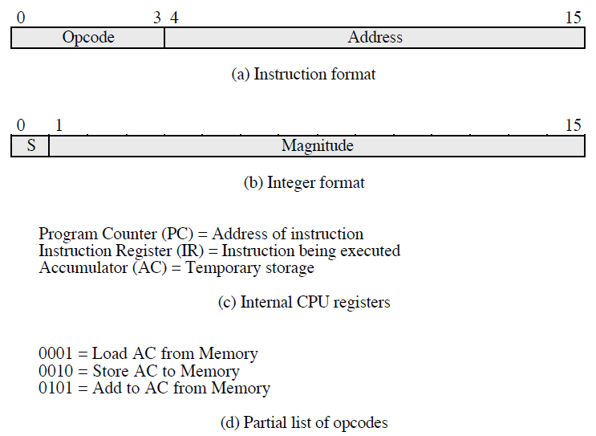

The hypothetical machine also has two I/O instructions:
0011 = load AC from I/O
0111 =store AC to I/O
In these case, the 12-bi address identifies a particular I/O device. Show the program Execute for the following program:
1. Load AC from device 5.
2. Add contents of memory location 940.
3. Store AC to device 6.
-Assume that the next value retrieved from device 5 is 3 and that location 940 contains a value of 2.

.Answer.

.Memory.
300 | 3005
301 | 5940
302 | 7006

After executing the three instructions..
-device 5 : 0003
-940 : 2
-device 6 : 0005

